NAME: TRADING CARD
PICTURE | Personal
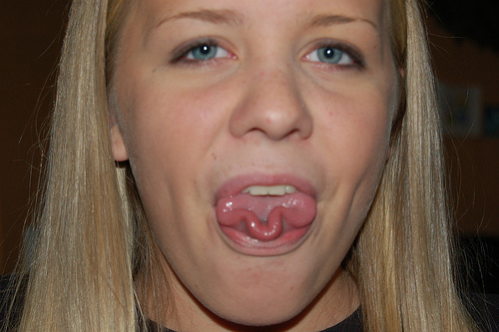 | Nickname: _________________________  Hometown: _________________________  I have ______ siblings.  Name(s): ____________________________________________________  I have ______ pet(s).  Name(s): ____________________________________________________  My hobby is/hobbies are _________________________________
Favorites / Passions/Peeves | Interesting Fact(s)
Favorite food: ____________________________________  Favorite film: _____________________________________  ________________________________________________  Favorite TV show: _________________________________  ________________________________________________  Favorite song: ____________________________________  ________________________________________________  Favorite color(s) __________________________________ | My biggest pet peeve is…  ____________________________________________________________  ____________________________________________________________  I am passionate about…  ____________________________________________________________  ____________________________________________________________  Interesting Fact(s):  ____________________________________________________________  ____________________________________________________________

