“For The Birds” Literary Elements Review

Setting (time and place): Characterization: (identify, describe and determine dynamic or static)
country: (evidence) rural area; cornfield; dirt road; isolated; no houses or cars
modern day: (evidence) telephone wire (invented 1876 but poles look more modern)
autumn: (evidence) group of trees in field w/colored leaves
daytime: (evidence) bright sun; birds chirping
Antagonist: unfriendly; cruel small birds: (evidence) first small bird reacts to second small bird that joins it on wire by making faces; mocks (make fun of) tall bird and will not allow him to join group on wire
Protagonist: friendly, kind, tall bird (evidence) attempts to befriend small birds with amiable greeting (waving and saying hello); flies over to join cruel, small birds; gives one mean, small bird a leave to cover its naked body; allows all mean, small birds to hide behind him

Themes:
Treat others how you want to be treated because you may find yourself in their position someday.
What goes around comes around: your unfriendly, cruel, or judgmental behavior may ultimately catch up to you someday.

Conflicts (describe and determine whether they are external or internal)
Unfriendly, cruel, small birds perched on telephone wire will not allow the friendly, kind, large bird to join their group or share the telephone wire. This is an external conflict because it is the large group of unfriendly, cruel, small birds against the friendly, kind, large bird.

“For The Birds”- Plot Structure Diagram

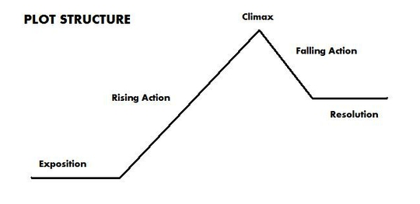Plot Structure:
Exposition: We meet small, blue unfriendly bird who is clearly unhappy about his fellow blue bird joining him on telephone wire. As more small, blue birds join them, they all react with unhappiness.
Rising Action: First unfriendly, cruel, small bird lands on telephone wire; joined by second unfriendly, cruel, small bird

