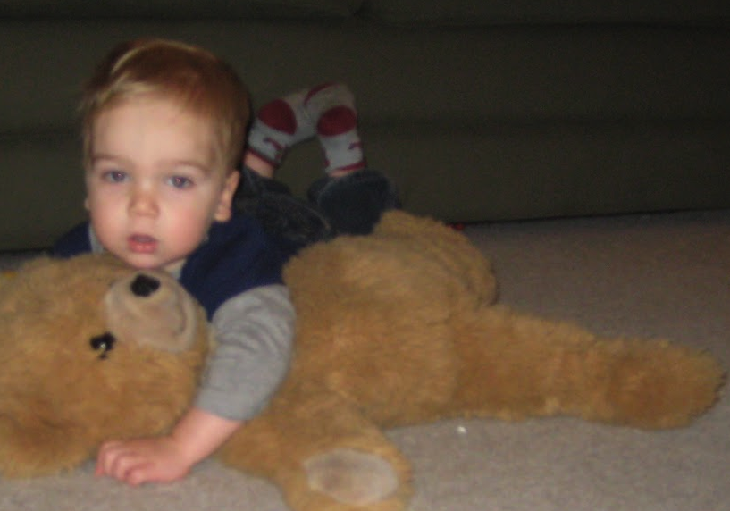
Anne Marie Ruvolo
Ms. Carota
English 10-period 3
9/10/14
Anne Marie
Complex, talkative, affectionate and candid.
Sibling of Melinda, Jennifer, Diana, and Courtney,
Four younger sisters who are never content on silence.
Lover of books that bring an escape into a separate world,
pictures that reveal the stories of the past,
a beloved Teddy bear – a constant source of security and comfort.
Who feels helpless to stop the depression that has set,
like an outsider, in a world where she once belonged,
tired of playing the game of pretend.
Who needs a break from the everyday routine,
to feel wanted and needed by others,
Who gives a listening ear and advice to any friend,
a realistic, if at times blunt, sense of reality,
love to those who take the time to look inside.
Who fears the world will continue to focus on trivial things.
and being alone in a life with no one who truly cares.
Who would like to see the fakeness of people disappear.
understanding and benevolence in a house now spilling over with fights and hatred.
and dreams made late at night to the stars, come true.
Resident of a small town on Long Island,
Where beauty still exists if people are willing to look for it
Ruvolo

