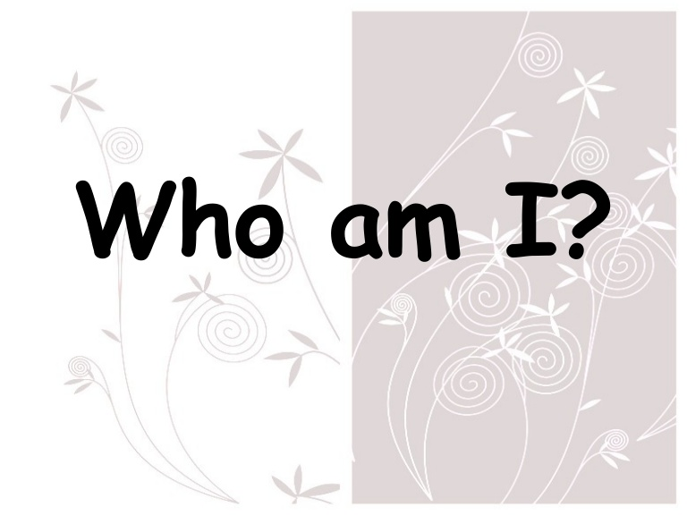
Name _________________________________________ Date ____________ Period ______ Ms. Carota

Bio Poem
What Carota is looking for in your Bio Poem….

Categories | Possible  Points | Earned  Points
four creative traits | 20
eleven original lines | 20
poem has depth, creativity, and engages reader | 20
poem should connect/reflect your adjectives | 20
interesting vocabulary | 10
interesting images | 5
mechanics | 5

100 / __________

