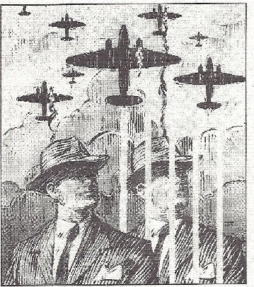
Name: _______________________________ Period: ______ All My Sons

Research and Discussion
1940s Assignment
Directions:
- Research the following nine (9) topics/ideas for America in the 1940s.
- Responses do not need to be in complete sentences, however, this activity will lead to a thorough and rich student-led conversation. Consequently, you MUST be prepared with research material to bring to the discussion. Use lined paper for additional research notes.
- Consider how life in America in the 1940s was similar or different from life today. Perhaps you can choose THREE of the topics you researched and use them to compare and contrast life in America in the 1940s and life in America today.
- The topics below are possible conversation springboards. Feel free, however, to bring other items you discover during your research to the discussion table.
- This paper will be collected after our discussion.

1. What were popular leisure activities?

2. Fashion?

3. Entertainment? (music, films, musicians, actors/actresses)

4. What were popular professions?

5. What were some big news stories?

6. Role of women?

7. Technology?

8. Who would have been drafted during WWII?

9. Effects of WWII?

