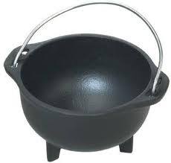
Recipe for a Witch
Ingredients:
- One large, cold, and empty cauldron.
- 1 ½ tablespoons of rage
- ½ cup of suppressed anger
- 3 cups of pale skin potion
- 1 creepy laugh - ground
- 4 tablespoons of darkness
- 1 teaspoon of pure hatred
Directions:
First, spray the cauldron with a non-stick agent, as a witch is very likely to stick to the pan, which will result in a very messy to clean up.

Once you’ve sprayed the pan, bring 1 gallon of water to a boil.
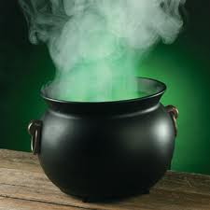
Once water has boiled, slowly add 1½ tablespoons of rage. Careful!
If entered into the mixture too quickly, it may result in a fatal explosion.

Stir the rage and water for approximately 1 minute.

When done, quickly add ½ cup of built up anger. If added too slowly
the anger will catch up to you and may again cause a fatal explosion.

Your brew should have a slight green glow and be very smoky.

Continuing your brew…

Once your brew has achieved a smoky look, you are in the clear as to how safely you should be when handling the ingredients.

Once you have the emotions of a witch brewing, you have to add their physical features.
First, you must stir in the 3 cups of pale skin potion, pouring and stirring at the same time, or else the substance will become pasty.

Once completely stirred, you must add in the ground creepy laughter. You will experience a very high-pitched squeal as you put the ground chunks into the potion.

Once mixed, you must slowly pour in the 4 tablespoons of darkness and the teaspoon of pure hatred.

To avoid too much commotion in your brew, add these ingredients smoothly and in darkness. Once all the ingredients are mixed into the brew, you must wait 10 decades for the witch to age.

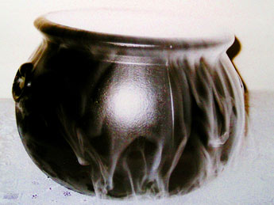
The final product before aging.

Happy Witching!

