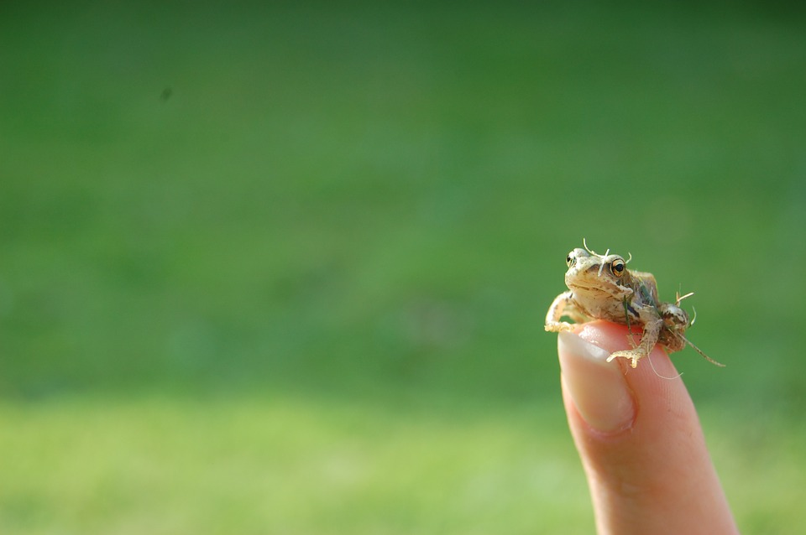

https://pixabay.com/en/users/jarmoluk-143740/

So small

Yet so mighty;

Perhaps not in size but in uniqueness.

Carol Carota 2017