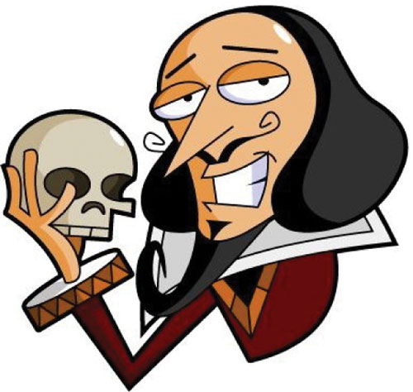
Name: _______________________ Period: _____
William Shakespeare’s Hamlet
What separates Hamlet from other revenge plays, and maybe from every play written before it, is that the action we expect to see, particularly from Hamlet himself, is continually postponed while Hamlet tries to obtain more certain knowledge about what he is doing, no small undertaking, even in modern times. This play poses many questions that other plays would simply take for granted. Can we have certain knowledge about anything? For example, in Hamlet’s case, can he be certain of the ghost? Is the ghost what it appears to be, or is it really a misleading fiend (i.e., Satan, sent here to tempt him and lead him astray.)? Does the ghost have reliable knowledge about its own death, or is the ghost itself deluded (mistaken)? Moving to earthlier matters: How can we know for certain the facts about a crime that has no witnesses? Can Hamlet know the state of Claudius’s soul by watching his behavior? If so, can he know the facts of what Claudius did by observing the state of his soul? Can Claudius, or the audience, know the state of Hamlet’s mind by only observing his behavior and listening to his speeches? Can we know whether our actions will have the consequences we want them to have? Can we know anything about the afterlife?

Regardless of which theme the reader focuses upon, the end result is the same: all of the main characters breathe their last, and it is up to us as the audience to ponder Shakespeare’s thought-provoking messages.

Some Important Themes:
- Appearance vs. reality and the difficulty of discovering and exposing the truth.
Some related scene evidence:
Act 1 Scene 3: Polonius instructs Ophelia to disassociate herself from Hamlet who he insists does not love her, regardless of what Hamlet may tell her.
Act 2 Scene 1: Ophelia, distraught, tells her father of Hamlet's recent bizarre behavior and Polonius now speculates that Hamlet is mad with love.
Act 2 Scene 2: Polonius tells Gertrude and Claudius of Hamlet's strange behavior and they agree to watch him secretly. Polonius talks with Hamlet who appears to be mad. Later in the scene Hamlet concocts his plan to trick the king with The Mousetrap play within a play scene, performed by the travelling players.
Act 3 Scene 1: In the 'nunnery scene' Ophelia is bewildered by Hamlet's contradictory assertions (love/hate declarations) and his anger and mourns the 'noble mind' that has been 'o'erthrown.'
Act 3 Scene 2: The performance of The Mousetrap play appears to reveal Claudius's guilt.
Act 3 Scene 4: Hamlet demands his mother face the truth of her disloyalty and says he will trust Rosencrantz and Guildenstern no more than he would 'adders fanged', knowing they have been dishonest in their dealings with him.
Act 4 Scene 7: Claudius concocts a plot with Laertes to kill Hamlet.

- Revenge and the complexity of taking revengeful action
Some related scene evidence:
Act 1 Scene 5: Hamlet promises his father’s ghost that he will avenge his murder but laments the responsibility he now bears.
Act 2 Scene 2: Hamlet berates his own passivity and contrasts it with the passion of the first actor for long-dead, legendary figures.
Act 3 Scene 3: Coming upon Claudius confessing the murder while trying to pray, Hamlet reconsiders killing the king when he is penitent (remorseful, conscience-stricken), deciding to wait until Claudius is sinning, thus damming his soul to hell.
Act 3 Scene 4: The ghost visits Hamlet while he is with his mother and reminds his son that he has not yet sought revenge for his murder.
Act 4 Scene 4: After his encounter with Fortinbras, Hamlet marvels that people kill one another over so slight a gain as 'a little patch of land' and resolves that from now on all his thoughts will be 'bloody.'
Act 4 Scene 5: In contrast to Hamlet's reflectiveness, Laertes determines on revenge without hesitation.
Act 5 Scene 2: Claudius's plot results in the death of most of the major characters. Before he dies Hamlet kills Claudius.
- Mortality and the mystery of death
Some related scene evidence:
Act 1 Scene 1: Marcellus and Bernardo tell Horatio that they have seen the ghost of old Hamlet. Horatio is skeptical until the ghost appears.
Act 1 Scene 4: Horatio, Marcellus and Hamlet meet the ghost. Hamlet, however, is the only one who speaks with it. Hamlet is unsure whether this is truly his father or an evil spirit, but insists that either way it cannot harm his immortal soul.
Act 3 Scene 1: Hamlet debates the question of whether suicide is an effective solution to the pain he is experiencing: the difficulty is that we do not know what to expect in “the undiscovered country from which no traveler returns”; no one has ever returned from the afterlife.
Act 5 Scene 1: Hamlet talks with the gravediggers and considers that even great men become dust. We all meet the same end, regardless of our social or economic position.

- Moral corruption and the consequent dysfunction of family and state.
Some related scene evidence:
As a result of Claudius’ immoral actions, namely killing his brother King Hamlet to gain the throne as well as Queen Gertrude, not only is there dysfunction within the royal family, but also within the nation of Denmark.

The death of the king throws Denmark into political turmoil as Young Fortinbras seeks to avenge his father’s death.
In the meantime, the deceased king's son, Prince Hamlet is also acting erratically, implying that something's clearly off.
When the guard Marcellus famously says, "[s]omething is rotten in the state of Denmark" (Act I, Scene IV), he’s referring to how something evil and vile is afoot. This moment could not only be interpreted as foreshadowing of the impending doom of most of the characters within the play, but also the political unrest Denmark is feeling as a nation. The political livelihood of Denmark can also be directly linked back to the mental state of Hamlet at many points throughout the play.

