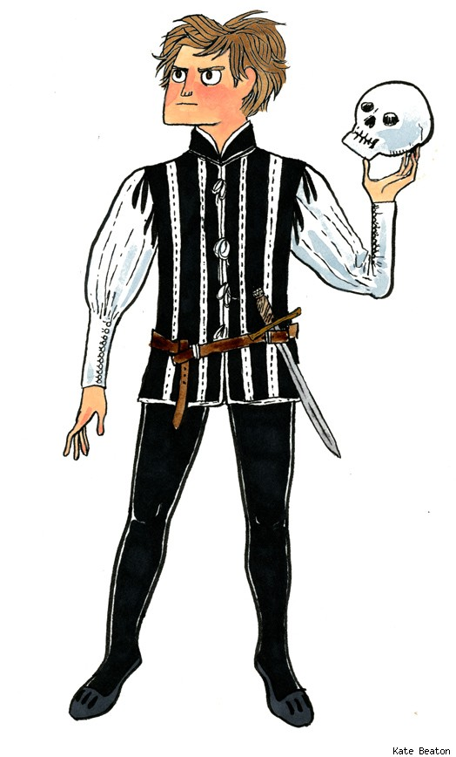

Welcome to English 12
2019/2020 Ms. Carota Room 167

Course Contract

I hope you and your family had an enjoyable summer. I look forward to making this a great year!
Please read the expectations and requirements for a successful 12th grade year, and then sign and return only the second-page portion of the contract. Hold onto this first page for easy reference.

Important Contact Information
Class website: http://mscarota.weebly.com (class website of assignments/resources)
Email address: ccarota@pmschools.org
Patchogue Medford High School Main Office: (631) 687-6500 (leave messages)
Castle Learning: www.castlelearning.com (mandatory online review and practice)
Remind 101: students required to participate using teacher-provided class code unique to their class period; parents are encouraged to participate as well.

Required Materials
A three ring binder is REQUIRED and must be brought to class daily. NO SPIRAL NOTEBOOKS, PLEASE.
A blue or black ink pen is needed DAILY. We rarely use pencil.
Quarterly & Final Averages:
Quarter 1: 20%
Qu Quarter 2: 20%
Quarter 3: 20%
Quarter 4: 20%
Mi Midterm: 8%
Final: 12%

Grading Policy
Tests/Writing Assignments/Projects 50%
Quizzes 40%
Homework/Class Work/Participation 10%

Guarantee of Success
Students are expected to come to class each day on time and prepared with the necessary materials.
Students are expected to listen attentively, follow directions, participate in discussions, and behave appropriately.
Students are responsible to make up missed work when absent and follow up with me upon return to class.
Students are expected to regularly monitor class website for homework or missing work when absent.
Cell phones, iPods, and other electronic devices are NOT permitted in class.

Missing and Late Assignments
If a student is absent, he/she must check the class website for missed assignments. Here students can also find handouts that may have been missed due to an absence. Of course, they can ALWAYS check in with me as well.
Late assignments will lose five points for each day late up to five days late.
Assignments more than five days late will result in a zero.
Tests and quizzes must be made up in a timely manner.

Extra Help & Office Hours
Extra Help: Monday and Wednesday from 1:57-2:27PM. Office Hours: Thursday from 2:27PM-2:57PM.
I will also try my best to be available at other times if a student would like to come in during a time other than those listed above. All students must sign up on the extra help sign-up sheet to notify me that you will be attending.

Attendance Policy
As per the district policy, full-year courses require that students in excess of 28 absences will not receive credit for the course.
Remember, a positive attitude and genuine effort count!
-------------------------------------------------------------------------------------------------------------------------------
Sign and return only the second-page portion to Ms. Carota
Please keep this page for your records.

Page 2 – English 12 Course Contract

Return ONLY this page to Ms. Carota.

Ms. Carota English 12 Course Contract

COMPLETE ALL INFORMATION AND PRINT NEATLY.

Student Name: _____________________________________________________ Period: _______
First Name Last Name

I have reviewed the above information with my child and understand what is required for English 12.

_________________________________________ _________________________________________
Student Signature Date Parent/Guardian Signature Date

**IMPORTANT NOTE to PARENTS(s)/GUARDIAN(s)**: I firmly believe that dialogue is crucial for student success. Consequently, I am asking each parent/guardian to provide his/her email address that we might keep open the lines of communication throughout the school year. Please provide this information at the bottom of page two (2) of this contract. Throughout the year, I welcome any questions, concerns, and/or comments that help to ensure your child’s success and encourage you to keep in touch via email.

COMPLETE ALL INFORMATION AND PRINT NEATLY.

_____________________________________________________________________________ Mother/Guardian Email Address AND/OR Cell Phone #

_____________________________________________________________________________ Father/Guardian Email Address AND/OR Cell Phone #

Thank you, and I look forward to a great year!

