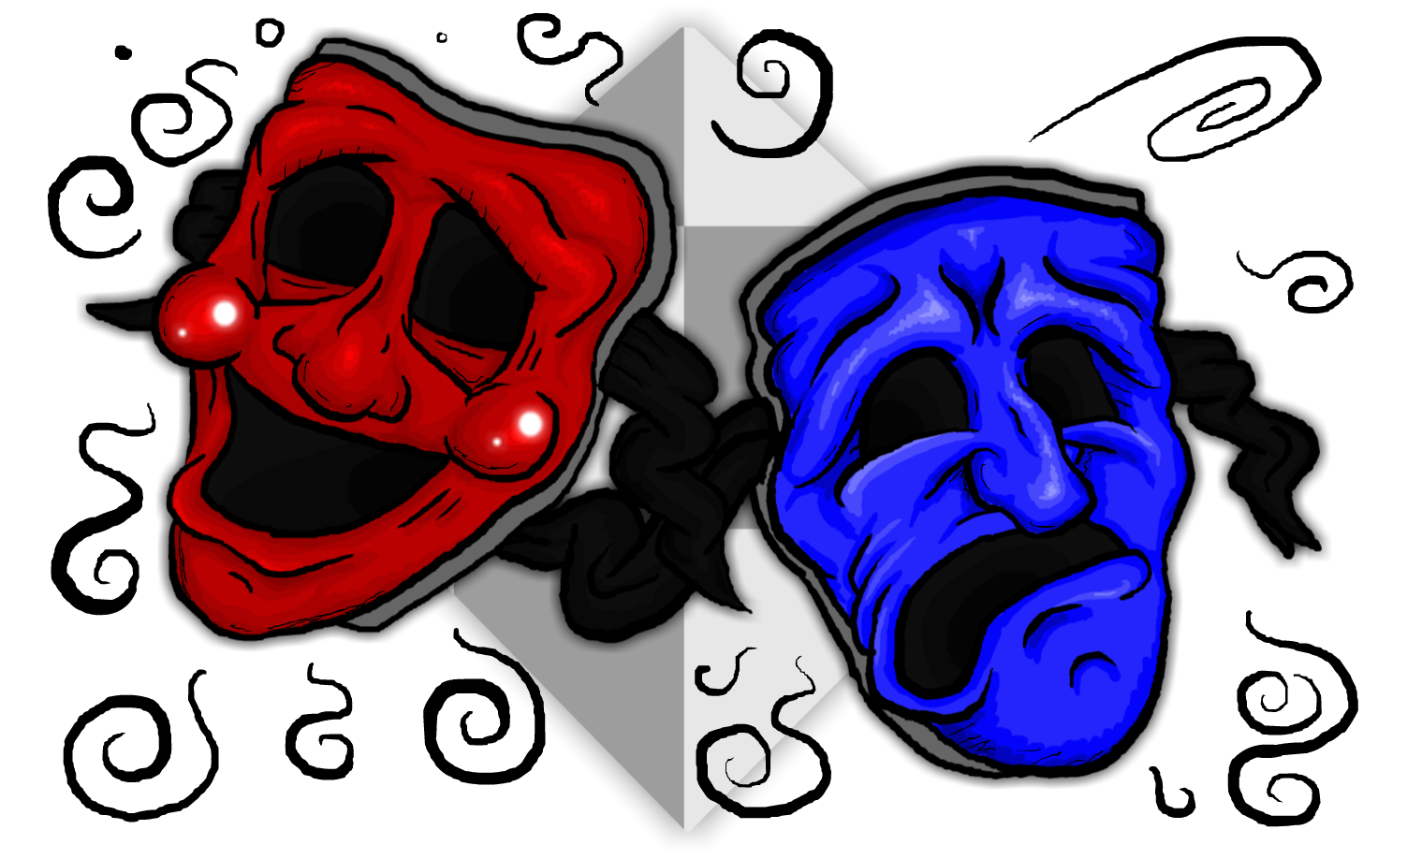
Name: _______________________________ Period: ______ Ms. Carota/Theater

Character Development
Part I:
Complete the Character Sketch Template, below.

Who am I?
Name:
Age:
Family situation:
Eye color:
Hair color:
Personality traits:
Passions:
Pet peeves:

Where am I? In other words, what are the location and conditions of my environment?

What time period am I in?

What is my major goal in this monologue or scene?

Why is this goal so important to me?

Are there any events in my past that might affect the significance of this goal?

What or who is the way of obtaining this goal?

What do I do to obtain this goal? (Think ACTION verbs; physical, verbal, and/or psychological)
1.

2.

3.

What is my relationship with other people connected to this monologue or scene?

)

