Name: _____________________________ Period: __________
Blackout Poetry Project Instructions
Blackout or “redactic” poetry is created by choosing certain words and/or phrases on an existing page of text and then “blocking out” the remaining words to create a poem.

Directions:
- Read the provided passage and
- contemplate and choose one of the novel’s themes.
- choose and lightly underline in pencil those words and/or phrases that speak to your chosen theme; start by looking in the first paragraph, or first few lines of the page.
- continue down the entire page, underlining your word and/or phrase choices.
- Now that you have your chosen words and/or phrases
- reread your poem to ensure the sentence(s) make(s) sense and speak(s) to your theme.
- draw a bold box around all your chosen words and/or phrases to “draw out” your poem.
- incorporate a hand drawn or pasted image with your poem.

Below are some examples of blackout poetry.
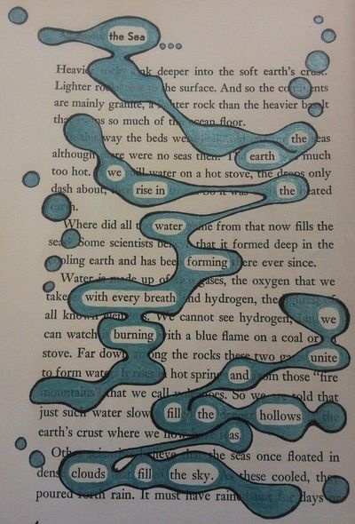
Notice how you are able to read the poems and understand the meaning behind them. Remember, the words MUST be in order, an image is included, and the page is appealing to the reader.

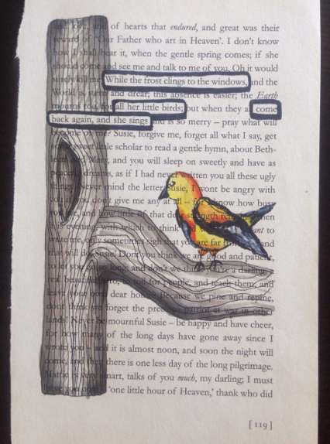

NEATNESS COUNTS! NEATNESS COUNTS! Messy coloring, scribbling,
incomplete or amateur drawings, or simply blackening out entire page, with the exception of the poem, is not acceptable for this assignment.
Be creative and have fun!

