Name___________________________ Period_____ Ms. Carota/English

What Is Reading All About?
Author’s Purpose

As readers, You must become like Sherlock Holmes 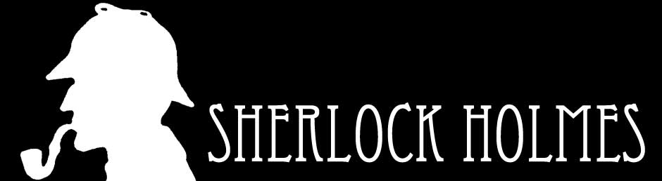 and consider and analyze the following:

What is the author’s purpose?
(theme /central idea / main idea)

Depending on the text type, the answer to the above question will vary slightly…

FICTION NON-FICTION
(short story, novel, poem, etc.) (newspaper article, speech, essay, etc.)

Its central idea comes in the form of Its central idea comes in the form of a
a theme (lesson, moral or message) that main idea that informs, persuades, or
informs or teaches. entertains.

Review:
1. Identify author’s purpose: theme {fiction} or central idea/main idea {non-fiction}
2. Identify how the author gets this central idea/main idea across to the reader. In other words, which literary techniques or elements does the author use to help readers make connections? Use Literary Devices handout to assist you in this endeavor.

