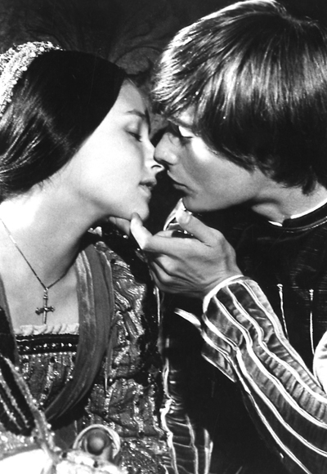
Name: _____________________________________________ Period: ________
Ms. Carota/English

Romeo and Juliet
Act II, sc. 6

FRIAR LAWRENCE:

These violent delights have violent ends
And in their triumph die, like fire and powder,
Which, as they kiss, consume. The sweetest honey
Is loathsome in his own deliciousness
And in the taste confounds the appetite.
Therefore love moderately. Long love doth so.
Too swift arrives as tardy as too slow.

